Tips for Recording Your Lesson

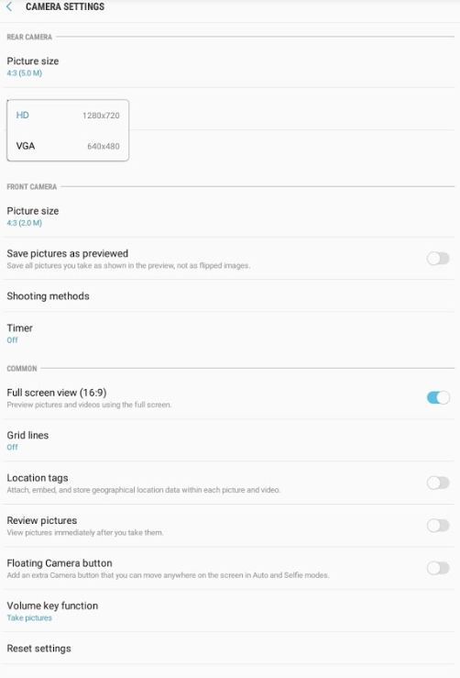
1. Become comfortable using the tablet’s camera feature by practicing.
2. configure the camera’s settings.
The screenshot to the right should match your tablet’s camera settings. Be sure to select “Full screen view (16.9).”

3. position the camera correctly.
On the following page you will find diagrams to help you find an appropriate spot to set up the tablet for filming. The tablet can be propped up on a shelf or table. When you look at the camera screen, you should be able to see the following three things:
- The materials needed for the activity;
- Children with video consents (children without video consents should be avoided); and
- Where you will sit or stand to teach.

Keep the camera angled at eye level. This will ensure that you will be in the camera’s view whether you are standing or sitting. Feel free to use blue tape or a chair to mark where you will be to ensure you will be captured in the video. Make sure the camera faces away from windows and lamps to create a bright and clear video. If you film in front of windows and lamps, then the video will be too dark to see.

4. Introduce the Camera to students.
- Prepare the students by explaining to them that you will be using a tablet to film some group settings during the day.
- Inform the children that they are not allowed to touch the tablet.
- Tell the children to pretend the camera is invisible and to pay attention to you as they normally would.

5. when you’re ready to START FILMING:
- Make sure that the materials for the activity are clearly visible, that the camera shows only the children with video consents, and that you will also be seen in the video.
- Press record. Double-check the camera recording indicators to ensure that the camera is recording.
- Go to the blue tape position or chair to begin your instruction.
- Talk in a loud voice. It is important to be able to hear what you and your students are saying.

Camera Positioning Diagrams

Below are diagrams that will help guide you on how to best position the children with video consents so that only they appear in the video.

Whole group
Begin by positioning the camera at eye level (note this changes whether you are sitting or standing) about 20 steps away from where you will be during the activity. Arrange students so that the faces of those students who do not have signed consent forms are less likely to end up in the camera’s view.

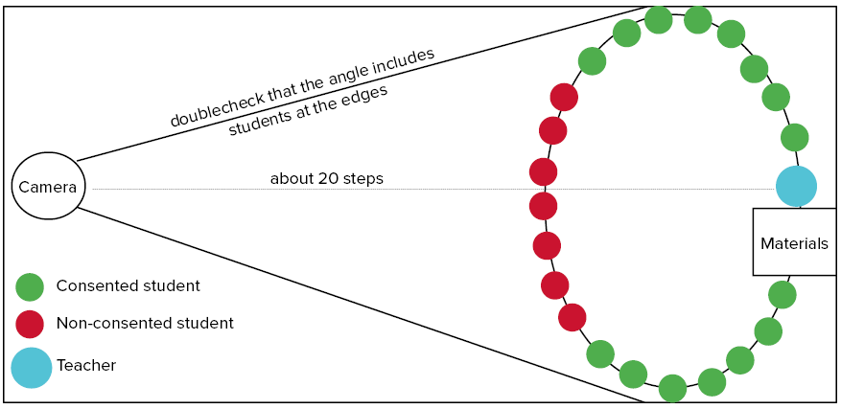
small group
Try to choose a group to videotape where all of the children have video consents. If all groups are a mix of consented and not consented children, then select the group with the highest number of consented children. Arrange students so that those who do not have signed consent forms will not end up in the camera’s view.

